 www.smart911.com/HolidayHazards Social Media Content

Be sure to follow the Smart911 accounts at www.facebook.com/smart911 and www.twitter.com/smart911. When copying and pasting a post from below, you will need to delete and retype @smart911 in order to tag our account in the post. All images can be downloaded from www.safety.smart911.com/holidayhazards

FACEBOOK

The holidays are filled with bright colors, lights, and poisonous plants. Keep mistletoe, holly berries, Jerusalem berries and other harmful plants away from your children and pets this holiday season. @Smart911
<add image>
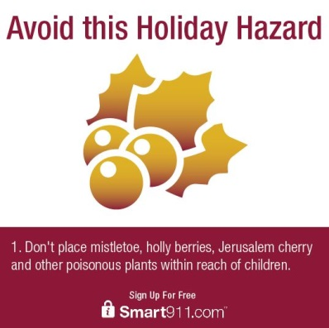

4 out of 5 burglars admit to using social networks to locate empty homes. This holiday season, avoid posting your travel plans on social media and protect your home by signing up for @Smart911
<add image>
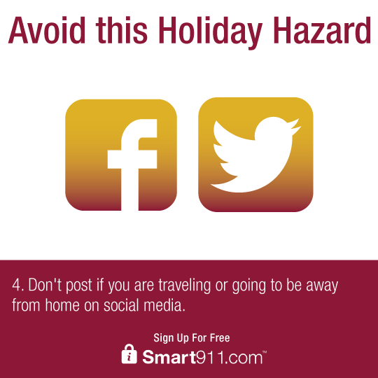

Are you aware of the most common holiday safety hazards? Keep your home and family safe this season by signing up for @Smart911.
<add image>
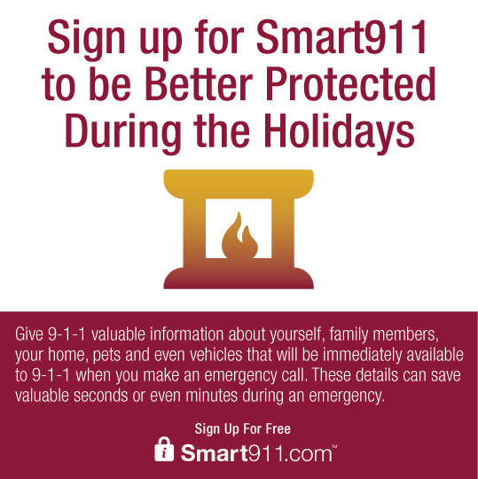

TWITTER

11,000 people end up in the hospital due to holiday decorating injuries. Avoid these hazards & sign up for @Smart911
<add image>
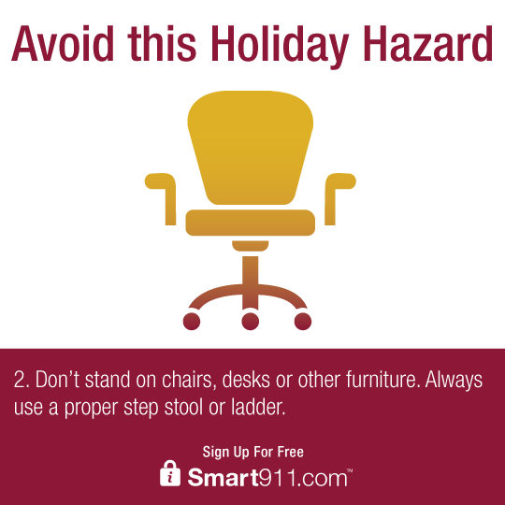

Did you know most kitchen related accidents involve dull knives? A sharp knife reduces potential for injury @Smart911
<add image>
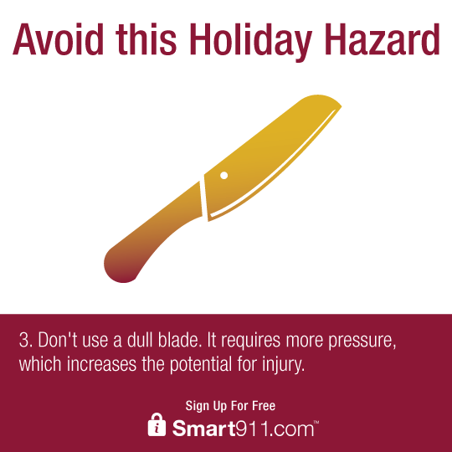

Christmas trees cause an average of 230 home fires each year. Be smart about holiday hazards & sign up for @Smart911
<add image>
